
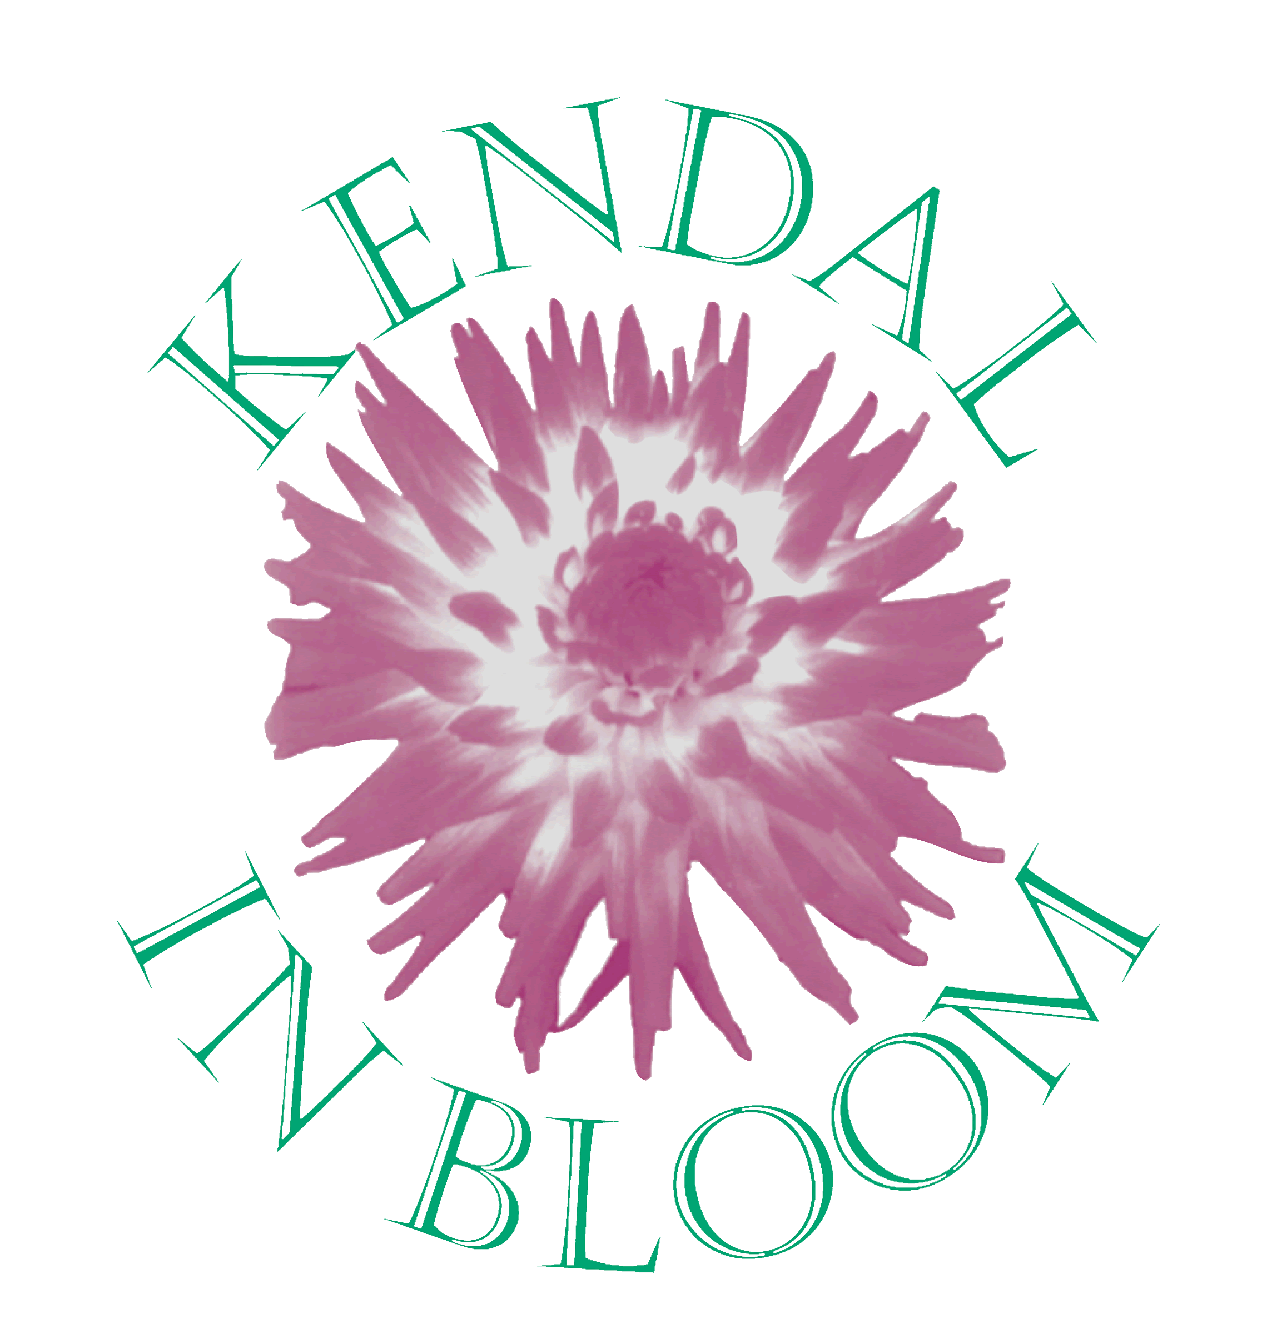
Kendal in Bloom 2015
Sponsorship Form

Business Name | Address
I would like to make a contribution to the 2015 Kendal in Bloom Sponsorship fund and attach my donation herewith.

I understand the donation will be used to go towards the planting and floral displays of Kendal.

Cost to Planters Spring/Summer 2015 Autumn/Winter 2015/16
Plant up
per season
How many How many

£170 – 4 Tier Floral Fountains

£170 – Large Tree Tubs

£110 – 3 Tier Floral Fountains

£60 – Large Trough

£40 – Baskets/Small Trough

I would like to sponsor a category in the Kendal in Bloom Competition
and make a donation of £

I would like to make a donation of £ I would like to donate a
raffle prize
Please send your donations to:-

Assistant to the Town Clerk
Kendal Town Council
Town Hall
Highgate
Kendal
LA9 4DQ

Please make cheques payable to ‘Kendal Town Council’.
Thank you.

