Please use this form to apply for a Festival Support/Development Grant from Kendal Town Council. You must complete all the boxes on the form and submit it along with the required paperwork. On receipt of this form you will be given a date when your application will be considered by the relevant committee.
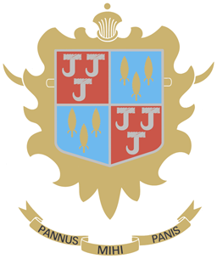
Kendal Town Council
Festival Support/Development Grant
2022-2023
Name of Organisation |  |  |  | Principal Contact
Address of organisation |  |  |  | Address of contact
Date of application

Telephone

E-mail

Description of organisation
How much funding do you require in total?
How much funding are you requesting from the Town Council (maximum £500)
Have you approached other funding sources? If so, please list them and the amount you have applied for.
Tell us what you will do with a grant from Kendal Town Council?
How will your festival benefit the people of Kendal?
How will your festival help to reduce Kendal’s Carbon Footprint?
Do you have a constitution?  Please send a copy with your application |  |  |  |  | Yes/No
Bank Details – How does the name of your organisation appear on your bank account?
This is who we will transfer funds to, should your application be successful.
Please include the following documents with your application
- Most recent bank statements and last audited accounts
- Constitution of group. This must include a statement on how you promote equality
Declaration
- I/we understand that grant money from Kendal Town Council must be used for the agreed purpose.
- I/we will abide by the conditions of funding.
Please note that we do require 3 signatures in order to present your application to Committee.
Signature |  | Name |  |  |  | Position
Signature |  | Name |  |  |  | Position
Signature |  | Name |  |  |  | Position

Please return completed forms by e-mail or post: Kendal Town Council, Town Hall, Kendal, LA9 4DQ. Email: office@kendaltowncouncil.gov.uk
Form ref KTC FDG1 2022

